CS 46B Lab Report

Darpan Goyal

I was the driver; Sidharth Khanna was the scribe.

Step 5

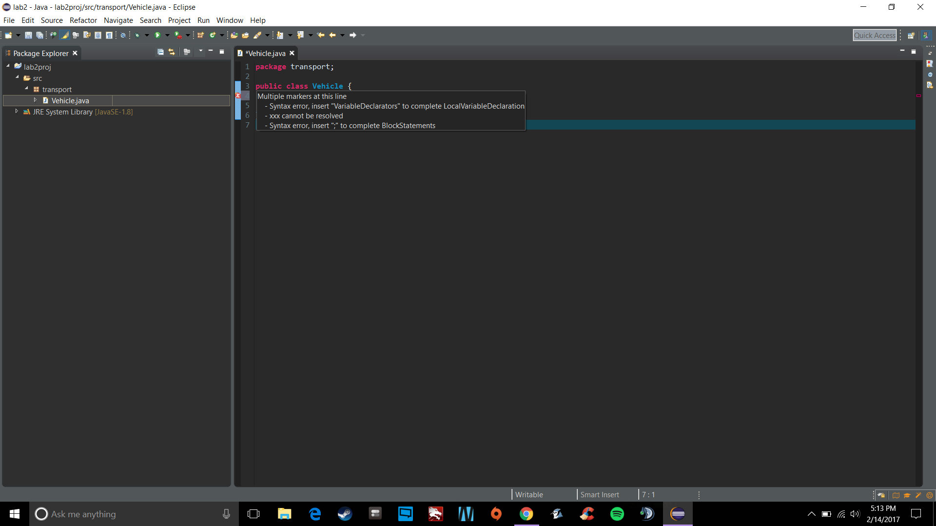

Step 7

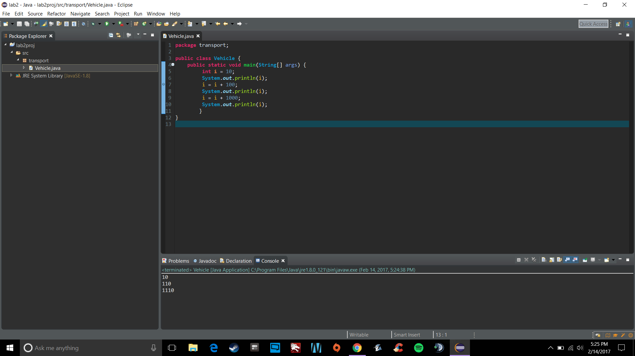

I understand that it is my responsibility to get familiar with more features of Eclipse

Step 10

Vehicle ctor

UnmannedVehicle ctor

MarsRover ctor

Step 11

Vehicle ctor

UnmannedVehicle ctor

MarsRover ctor

No more power

Step 12

Vehicle ctor

UnmannedVehicle ctor

MarsRover ctor

0

No more power

No, The rover isn’t likely to fall off the cliff, I am not surprised by the result.